**1/8/24 2- ASSIGNMENT OF IP ADDRESS MANUALLY 231901015**

**To configure your System and assign an IP address to the Hub:**

1. On your PC, navigate to the Ethernet network settings dialog.
2. Click the **Internet Protocol Version 4 (TCP/IPv4)** parameter.  
   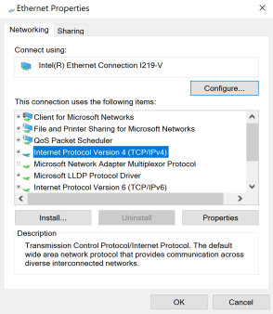
3. Click **Properties**. The **Internet Protocol Version 4 (TCP/IPv4) Properties** dialog appears.
4. Select **Use the following IP address**.  
   **Note IMPORTANT**: Make note of the current IP address entries for **IP address**, **Subnet mask**, and **Default gateway**. You will need this information to complete the final step of the process.
5. Configure with the following details:
   1. **IP address** for PC: 192.168.210.2
   2. **Subnet**: 255.255.255.0
   3. **Gateway**: 192.168.210.1

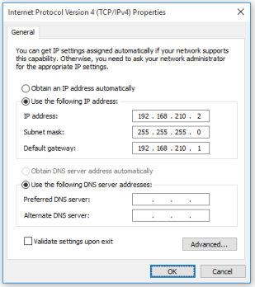

1. Click **OK**.
2. Open a browser window.
3. Enter the default gateway IP address to access the Hub: **192.168.210.1**. The Hub login screen displays.
4. Log into the Hub using the default user name and password. The default user name is **admin** and the default password is printed on the bottom label of the device and on the loose label included in the package. If the defaults to not work, they may have been changed. Confirm this information with your system administrator.
5. Update the IP address for the device.
6. On your PC, revert the IP address information to the original entries.
   1. Return to the **Internet Protocol Version 4 (TCP/IPv4) Properties** dialog.
   2. Enter the original IP address entries for **IP address**, **Subnet mask**, and **Default gateway**.
   3. Click **OK**.

